Objectives:

* TKINTER and DATABASES

This homework is based on Chapters 13-14.

**There are 2 projects, each worth 50%.**

**Project #1 (ERD DIAGRAM)**

Create and design the three tables below with primary and foreign keys. Be sure to enter the information displayed on each table.

Then join the three tables into one. Print screen the output below.

**#1 Print screen the SQL JOIN output below here.**

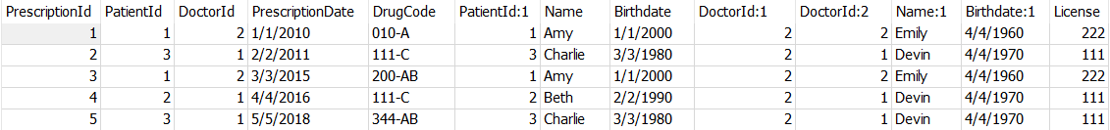

Code:

SELECT *

FROM prescriptions pr

INNER JOIN patients pa ON pr.PatientId = pa.PatientId

INNER JOIN doctors dc ON pr.DoctorId = dc.DoctorId

**Project #2 (TKINTER CONNECTION).**

**Note:** refer to (m5 Ch13 and Ch14 TKINTER and Databases (Username and Password) + class exercise #5 Part 3) to complete this section.

Your task is to create three forms, one for each table. The program will have the capability to **insert**, **delete**, and **update**. Design the windows in any fashion but make them as professional-looking as possible.

*PLEASE USE A RECORDING DEVICE TO RECORD YOUR APPLICATION AND COPY AND PASTE THE LINK TO THE RECORDING BELOW HERE. Please explain how the insert, update and delete buttons work, and how you can navigate from window to window.*

URL Link:

<https://screenpal.com/watch/c0iD0hVgNIq?utm_source=sendinblue&utm_campaign=Share%20Video%20-%20Recipient%202023&utm_medium=email>

For the project, I created two files:

* m5_homwork.py – this is the python script that creates one main form.
* SQLLiteDAL – this is the python data access script that performs the get, insert, update, and delete functions.

On my main form, I have 3 tabs representing the 3 subject areas (patients, doctors, and prescriptions). Clicking on each tab will allow the user to reference the 3 different SU.

The main form references the SQLLiteDal file to perform database tasks. I have one set of Insert, Update, and Delete buttons on the form. The code checks to see which Tab is selected and perform the necessary action of the subject areas. The Delete button performs a data integrity check before deleting the record.

Please note that I created foreign key constraints on the prescription tables to the patients and doctors tables. However, it seems that SQLLite does NOT enforce the foreign key constraints. I’m still able to delete the patient or doctor being referenced in the prescription table. Hence, I had to create my own data integrity check before deleting.

**Submit this document to Module 5 Homework.**